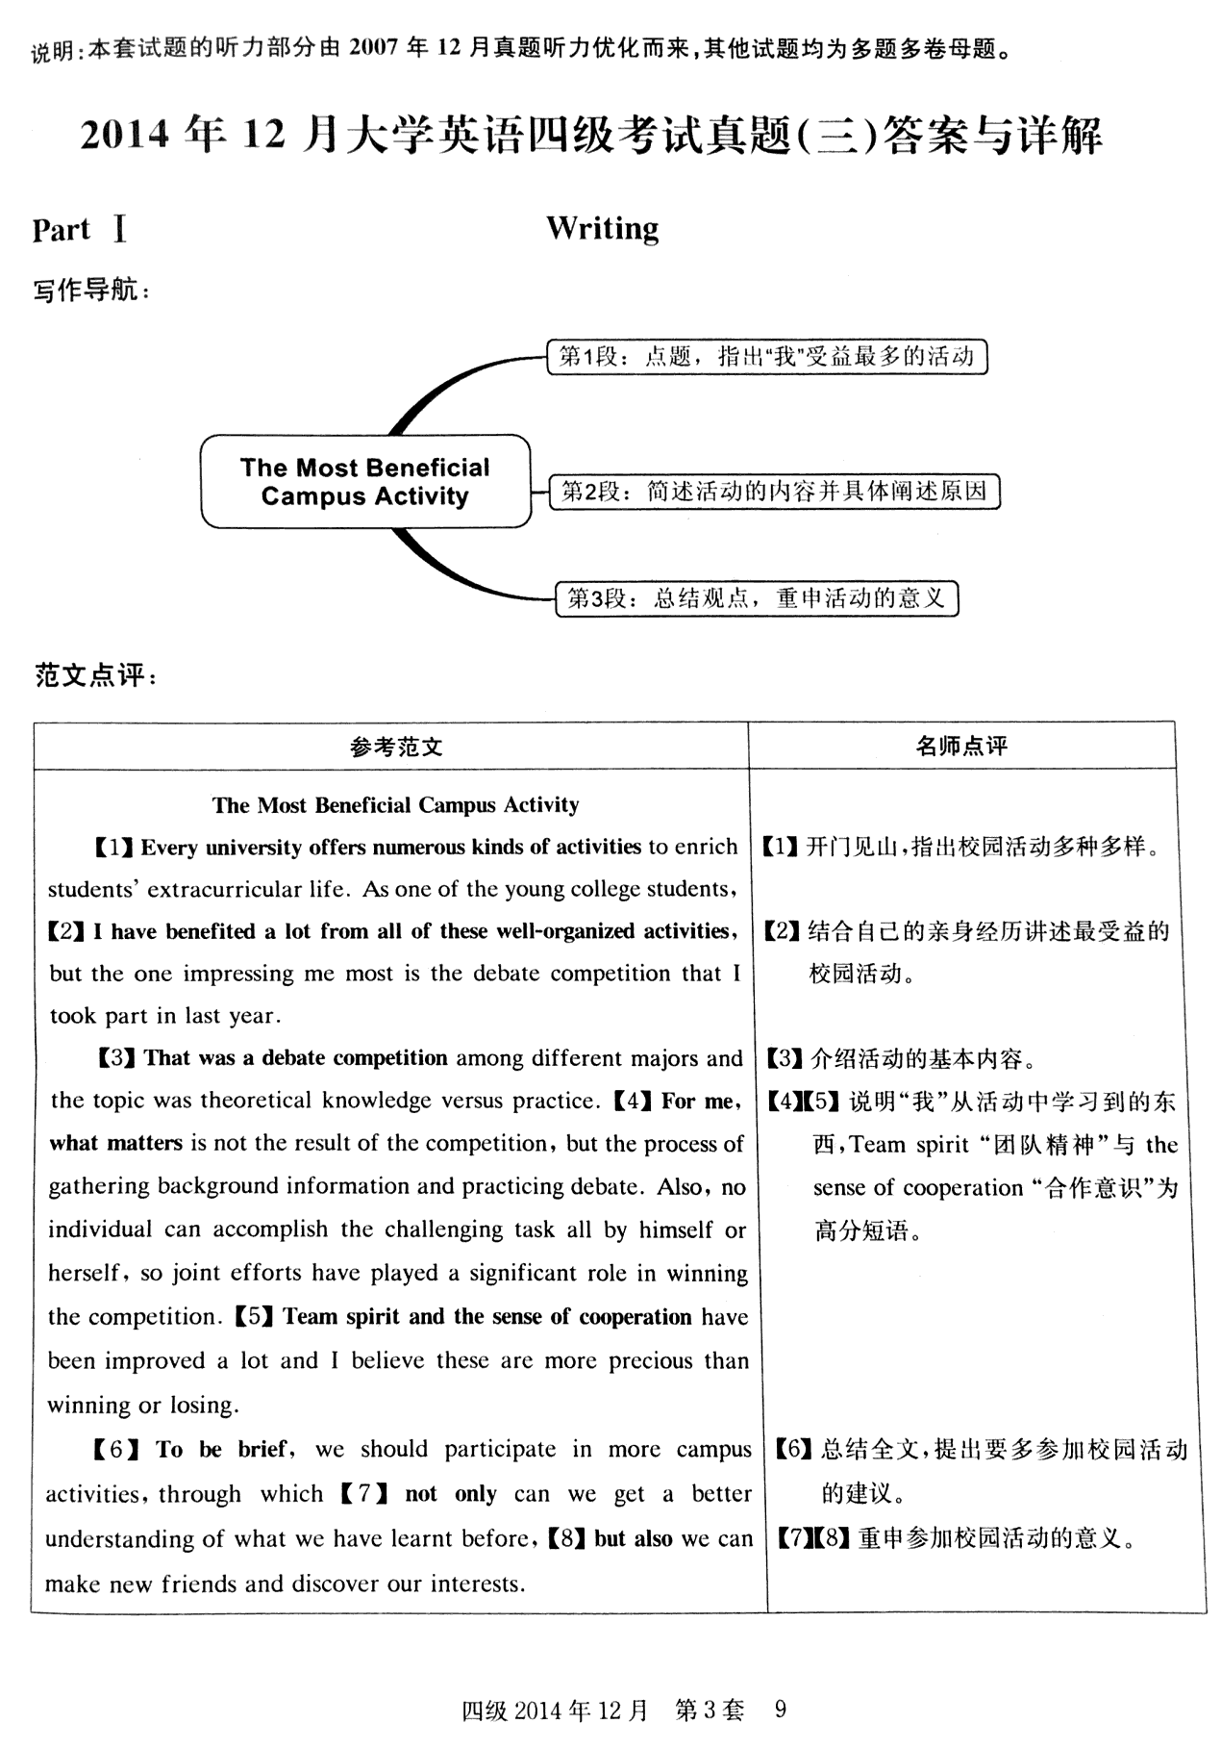

26-35 FDKNCEBIGH

36-45 BNMAECGOHL

46-50 BBCAD

51-55 BCBAD

